Activity 1
Code
#include <stdio.h>
#include <unistd.h>

int main(void) {
int pid;
printf("I am the parent process and pid is: %d .\n",getpid());
pid = fork();
if (pid == 0)
printf("I am the child process and pid is :%d.\n",getpid());
else
printf("I am the parent process and pid if my child is: %d .\n",pid);
}
Output
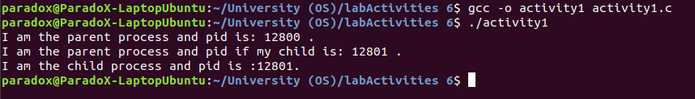
Activity 2
Code
#include <stdio.h>
#include <unistd.h>

int main(void) {
int pid;
printf("creating child");
pid = fork();
if (pid == 0){
sleep(5);
printf("orphan child exiting\n");
}
else
printf("parent exiting\n");
}
Output
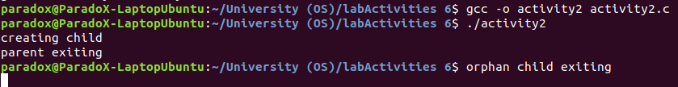

Activity 3
Code
#include<stdio.h>
#include<stdlib.h>
#include<sys/wait.h>
#include<unistd.h>

int main(void) {
int pid;
printf("creating child");
pid = fork();
if (pid == 0){
exit(0);
}
else{
sleep(100);
}
}
Output

Activity 4
Code
Output

Activity 5
Code
pt1:
#include<stdio.h>
#include<stdlib.h>
#include<sys/wait.h>
#include<unistd.h>

int main(void) {
char name[100];
char universityName[100];

printf("Enter your name : ");
scanf("%[^\n]%*c", name);
printf("Enter your University name :");
scanf("%[^\n]%*c", universityName);
execv("./activity5_pt2", NULL);
}
pt2:
#include<stdio.h>
#include<stdlib.h>
#include<sys/wait.h>
#include<unistd.h>

int main(char *argc, char *argv) {
char degreeName[100];
char departmentName[100];
printf("Enter your degree name : ");
scanf("%[^\n]%*c", degreeName);
printf("Enter your department name : ");
scanf("%[^\n]%*c", departmentName);
}
Output

